**Level 1: Charles Babbage & Ada Lovelace**

1. Who was Charles Babbage?
   1. When and where was he born?

Charles Babbage was born on December 26th, 1791 there are no whereabouts of where as it was long ago but people believe it was in London and in the district of Southwark which is part of Central London.

* 1. What was his main contribution to computer science?

His main contribution and most famous one was designing a programmable computer device. He is considered the father of the computer and he has the honor of holding the title for devising the first mechanical computer ever. He also has designs for hundreds of other super complex machines at that time.

1. What is the "Difference Engine" proposed by Charles Babbage?
   1. What did it do?

It was an automatic mechanical calculator designed to work out polynomial functions. It got its name from the method of divided differences which is known as a way to calculate functions by using a small set of polynomial coefficients.

* 1. How did it work?

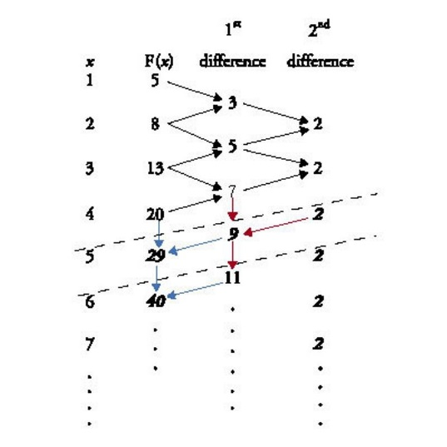The difference engine worked in a cool way it had certain patterns when it comes to odd number and even numbers. Down below is a diagram of how it works you can adjust the size if you want to see the diagram.

* 1. How was it similar to modern computers?

It is similar to the fact of numbers being used in coding and the engine in general. Most computers were based off of the analytical engine which I will be talking about down below.

1. Who was Ada Lovelace?
   1. When and where was she born?

She was born on December 10th, 1815 and in the country of England and the city of London. It also not fully known as this was a very long time ago and nothing is sure.

* 1. What was her main contribution to computer science?

Ada Lovelace was known for the influential contribution she made to the analytical engine and she was also named to most as the first computer programmer.

* 1. What is the computer language that is named after her?

Ada Lovelace was the first to recognize to have “program” and she published the first algorithm intended to be carried out by the analytical engine.

1. What is the "Analytical Engine" worked on by Ada Lovelace?
   1. What did it do?

It was a “computer” incorporated with an arithmetic logic unit, control flow the form of conditional branching a loop which also contained memory which gives it the definition of a computer.

* 1. How did it work?

It was a general-purpose programmable computing engine and was more advanced than the difference engine as this was made after and it included the characteristics of the difference engine adding the effect of control flow and also having memory which helped backtrack multiple things done on it.

* 1. How was it similar to modern computers?

The analytical engine has many things in it which is now found in modern computers. To start off, it was programmable using punched cards which some computers still use to this day. Also capable of functions for which we have modern names: conditional branching, looping (iteration), microprogramming, parallel processing, iteration, latching, polling, and pulse-shaping, amongst others,

**Level 2: Alan Turing**

1. Who was Alan Turing?
   1. When and where was he born?

Alan Turing was born on June 23rd, 1912 in Maida Vale, London, England and died on the 7th of June 1954 the age of 41 in Wilmslow, Cheshire, England.

* 1. What was his main contribution during World War II?

His main contribution during World War II was breaking the German Enigma code and many believe he is the reason why we won the war.

* 1. What were his main contributions to computer science after World War II?

He also went on to break the Naval Enigma, a more complicated machine he ever worked on before. He could not do much more as he died a young tragic death due to the gruesome laws back in the earl 1900’s.

1. What is the "Enigma" that Alan Turing worked on during World War II?
   1. What was the "Enigma code" used by the Germans and how did it work?

It was made up of a series of electro-mechanical rotor cipher machines, developed for the World War so the allies couldn’t track the German’s moves. It was invented by a German engineer known as Arthur Scherbius at the end of WW1. It worked by looking like an oversize typewriter and once the first letter of your message on the keyboard as entered the light would light up German’s used this to determine messages which the British failed to recognize for so long.

* 1. Why was it so important for Britain to "crack" the Enigma code?

It was important because this allowed the German’s to dominate the war as the Allies knew nothing incoming. Many believe if this was not solved WW2 would have been a loss to the allies.

* 1. How did Alan Turing solve the puzzle?

Turing created a machine called the Bombe machine and this helped the British crack the code. The machine found a flaw in the encrypting messages qhich double-encrypted the first three letter at the beginning of each message this allowed the codebreakers to search for patterns and eventually find out the messages.

* 1. Why was Turing's work kept top secret?

It was kept a secret as the government didn’t want the enemies capturing Turing as this would cause a threat to a victory of the war. Also, they didn’t want anyone to know how they did it so the German’s can counter that it was quite smart they kept it secret as if they didn’t the war could have been changed dramatically.

1. Many people call Alan Turing the "Greatest Unknown Hero of World War II". Provide some examples of the impact of his work that would support this claim.

He is because this caused the war to flip and go in the favor of the allies. No one knew about the amazing things he done cracking the code and letting the British be a step ahead of the German’s countering their every move. Also no one knew about him and his goals for the war and this made him the greatest unknown hero of World War Two.

1. How did being gay affect Alan Turing's life and work as a computer scientist?
   1. How did being gay affect his work during World War II?

He was not trusted, people thought of him as a disease and an imposter. His work was not believed until he actually proved it. It brought him down and wanted him not to work but he fought through it.

* 1. How did being gay affect his work after World War II?

He was thrown in jail and tortured although the amazing things he’d done for Britain and it also went downhill from here. He turned depressed and wanted to end his life which is sad as he was super talented.

* 1. How did Alan Turing's life end?

Sadly, his life ended through suicide he drank cyanide which was a common poison he drank it due to the fact of him getting bullied and the sadness which came along of the people bullying him.

1. Many people call Alan Turing the "Father of Computer Science". Provide some examples of the impact of his work that would support this claim.

This is believed because he created something so impossible at the time no one could believe it. He decrypted something most computer scientists can’t do today, and he is looked up to helping Britain win the war. Without him the world would have been a mess and it is quite obvious of why people look up to him of being the Father of Computer Science.

**Level 3: Other Great Contributors**

1. Who was John von Neumann?
   1. When and where was he born?

Born December 28, 1903 in Budapest Austria-Hungary and died on February 8, 1957 in Washington D.C at the age of 53.

* 1. When and why did he move to America?

He migrated to America as he wanted a better life as well as for better education he officially became a citizen in 1937 along with his brother and his mother.

* 1. What was his contribution to mathematics & science?

He made important contributions to these fields as he looked into AI (Artificial Intelligence) he created many ideas including the von Neumann Machine.

* 1. What was his contribution to computer science?

He created a design model for a stored-program digital computer that uses a processing unit and a single separate storage. Which held both instruction and data.

1. What was the "ENIAC" computer and the "von Neumann Machine"?
   1. What did it do and how did it work?

The ENIAC is known as the Electronic Numerical Integrator And Computer and it was the world’s first general-purpose computer. It was designed for the US army to calculate artillery firing tables. The von Neumann Machine was a stored-program digital computer that uses a processing unit and a single separate storage. Which held both instruction and data.

* 1. How is it related to modern computers?

Because the computers now a days still use similar features from the boot and reboot as well as calculating in applications which the computer calculates numbers for you an example can be in arrow games where the computer calculates the calculations of the arrows.

* 1. Explain how a "von Neumann Machine" applies to modern PCs.

As now days computers have multiple storages, but it still has the similar part of the storage they both had the power to store memory and this is something PCs will always possess.

1. Who was Grace Hopper?
   1. When and where was she born?

She was born on December 9, 1906 in New York City and died on January 1st, 1992 at the age of 85 in Arlington, Virginia.

* 1. What were some of her contributions to computer science?

She was a pioneer of computer programming who invented one of the first compiler related tools and she popularized the idea of machine independent programming languages which also lead to the development of COBOL.

1. What was the "COBOL" computer language that Hopper helped to develop?
   1. How was COBOL different from other computer languages of the time?

It was different as it was designed for business use.

* 1. Is COBOL still in use today? Explain your answer.

It is still widely used today in legacy applications deployed on mainframe computer for example large scale and transaction processing jobs.

1. Who is Tim Berners-Lee?
   1. When and where was he born?

He was born on June 8, 1955 and is currently 63 years old and he was born in the country of England and the city of London.

* 1. Why was he knighted by Queen Elizabeth II?

It was for his success of building the internet and he was dubbed for his good deeds as a Knight Commander in 2004

* 1. What is his contribution to computer science?

His contribution to computer science was building the most used service ever, the internet and it is used commonly today in our everyday lives.

1. List some ways that your life would be different if Tim Berners-Lee did not invent the World Wide Web.

This class would not be possible as we do everything on the internet from research to work from daily activated to games. This assignment I am doing right now would not be completed as I researched every single question. We would have to read books for information and for essay’s instead of using the internet books would be the most useful item. Our life would be old style like the 1990’s the whole world would be completely different.

**Level 4: Presentation**

Pick one of the above "heroes" of computer science and prepare a brief presentation about their life and contributions.

Your presentation will be shared with other students in the class in a "trade show" format. (When we return form Christmas break.)

Your presentation should be shared with Mr. Nestor through Google Docs or via email at p0079141@pdsb.net.